**Technical Documentation**

**Title of the project:**

* Enhancing Payer Authorization Processes for Improved Operational Efficiency and Financial Impact.

**Abstract:**

* This project aims to analyse and improve payer authorization processes by identifying inefficiencies and their impacts on financial and patient outcomes. We derive actionable insights to streamline operations and enhance performance through data cleaning, exploratory data analysis (EDA), feature engineering, and visualization in Power BI. Key findings include areas of high processing times, payment discrepancies, and their correlations with patient health outcomes.

**Table of Contents:**

* Introduction
* Project Overview
* Data Collection
* Data Analysis
* Implementation
* Evaluation
* Conclusion
* References
* Appendices

**1. Introduction:**

* The project focuses on improving payer authorization processes within the healthcare industry. These processes are crucial for ensuring timely patient care and maintaining financial stability.
* The objectives include reducing processing times, minimizing payment discrepancies, and improving overall operational efficiency.
* Key terms include "payer authorization," "processing time," and "payment discrepancies.

**2. Project Overview:**

* The scope of this project involves analyzing authorization requests, claims, payer policies, and administrative processes.
* The project was undertaken to address operational bottlenecks and financial losses.
* The project faced constraints such as data completeness and integration from disparate sources.

**3. Data Collection:**

Data was acquired from multiple healthcare systems and included the following columns: Claim ID, Payer, Service Type, Claim Volume, Processing Time (days), Authorization Requests, Authorization Turnaround Time (days), Claim Resubmission Rates (%), Administrative Staff Turnover Rate (%), Cost Per Authorization ($), Revenue Cycle Time (days), Payment Discrepancies ($), Patient Wait Times (days), Patient Retention Rates (%), Patient Health Outcomes (scale 1-10), Data Completeness (%), Data Timeliness (days), User Adoption Rates (%), Payer Response Time (days), Payer Reimbursement Rates (%), Payer Policy Change Frequency (times/year), System Downtime (hours), System Response Time (seconds), Integration Success Rates (%), Training Hours, Resource Utilization Rates (%), and Staff Satisfaction (scale 1-10).

**4. Data Analysis:**

**Exploratory Data Analysis (EDA)**

* Identified missing and erroneous data.
* Standardized data formats and units.
* Merged data from different sources into a unified dataset.
* Performed statistical summaries and visualizations to understand data distribution and relationships.
* Data Cleaning Snippets
* 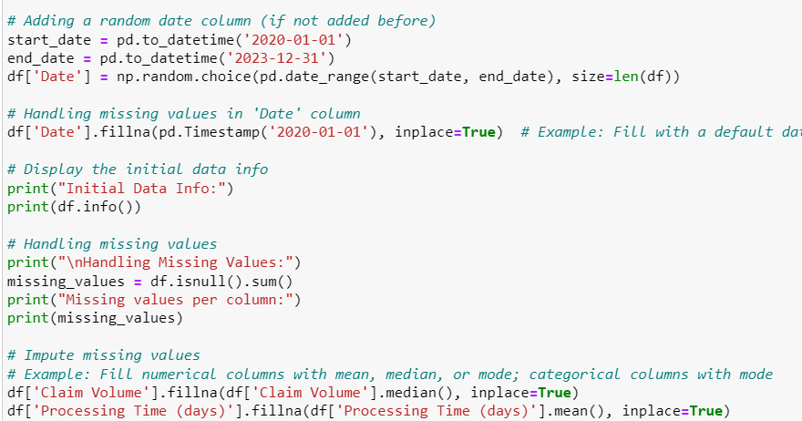
* 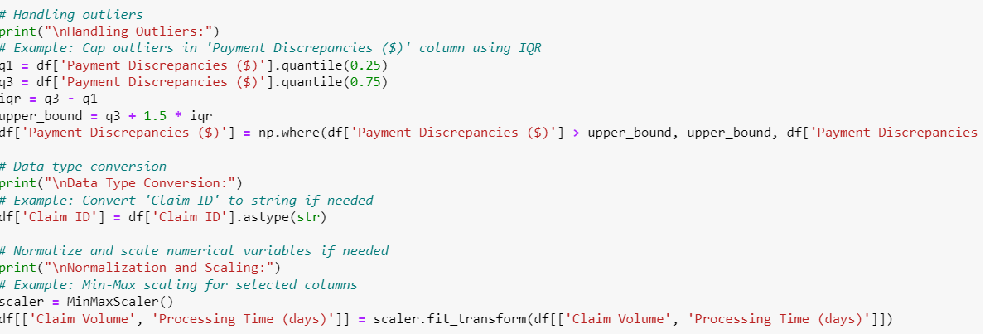

**Feature Engineering**

* Created new features such as 'Total Revenue Impact' based on available financial data.
* Aggregated and calculated metrics like average processing time, authorization turnaround time, and payment discrepancies.

**5. Implementation:**

* The analysis was implemented using Python for data preprocessing and EDA, and Power BI for visualization.
* Key Python libraries included pandas, numpy, and matplotlib. Power BI dashboards were created to visualize insights and support decision-making.

**6. Evaluation:**

* The analysis met project objectives by identifying key inefficiencies in the payer authorization processes.
* Challenges included integrating disparate data sources and dealing with incomplete data. Results were validated through comparison with industry benchmarks and stakeholder feedback.

**7. Conclusion:**

* The project identified several areas for improvement in payer authorization processes, including reducing processing times and minimizing payment discrepancies.
* Recommendations include process optimization, staff training, and improved data integration.
* Future work could involve deeper analysis of patient health outcomes and expanding the scope to include additional payers.

**8. References:**

* Documentation for Python libraries and Power BI.
* Case Study from HealthCare Catalyst.

**9. Appendices:**

* Include supplementary materials such as additional data tables, code listings, or technical specifications.